Distances measured:

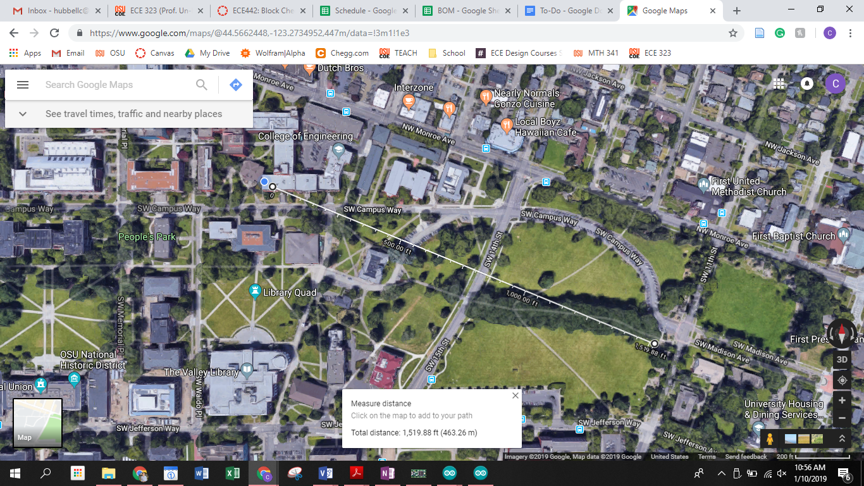

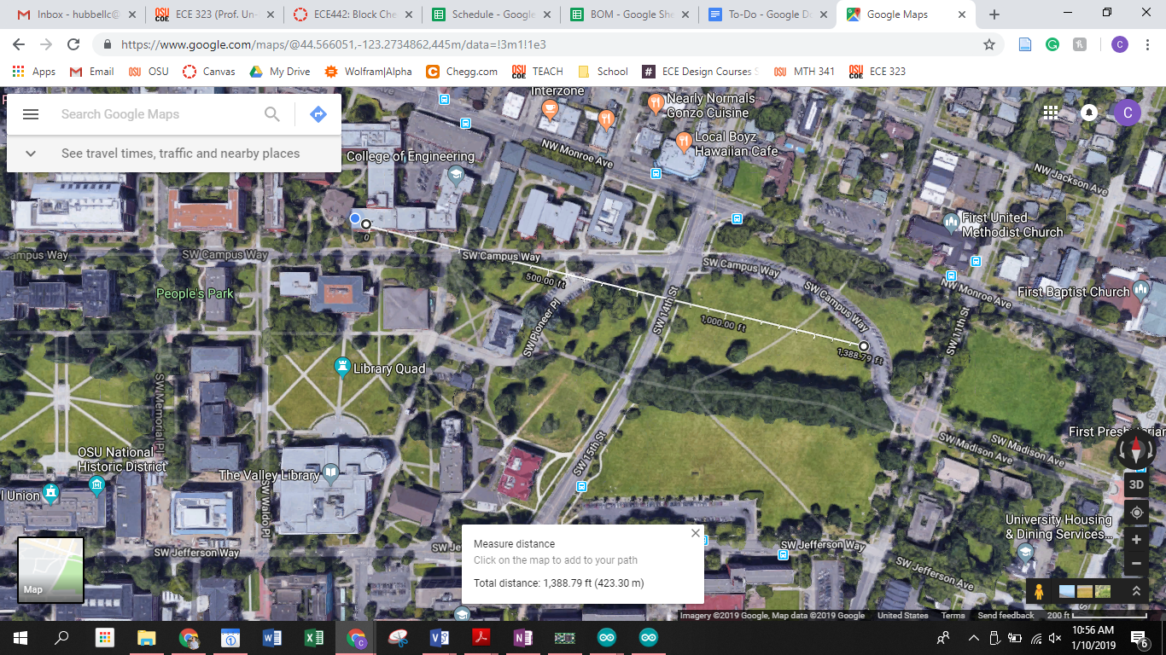

Videos from testing:

<https://drive.google.com/open?id=10PX0j_bxPoR-GgwA09c7Fp_l1E0qC7a6>

<https://drive.google.com/open?id=1wtWkWFRrGPw4KAitFrdB4BhjGA51nNVH>

<https://drive.google.com/open?id=1zHZFkzVGxAoUMuiNZZ8HjR49hUgMfTq3>

With Pi antenna mounted to 2nd window from the right in 211, and teensy traveling in laptop clamshell with antenna taped to teensy.

Max = 463.26m

Consistent = 423.30m

Goal = 400m